Pre-Calculus Important Formulas & Identities
p.1

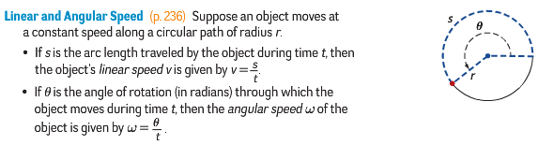

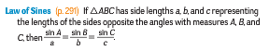
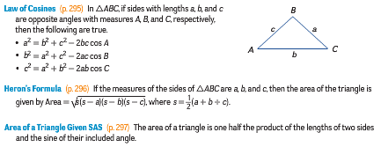
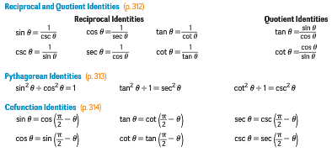
Pre-Calculus Important Formulas & Identities
p. 2

